  
  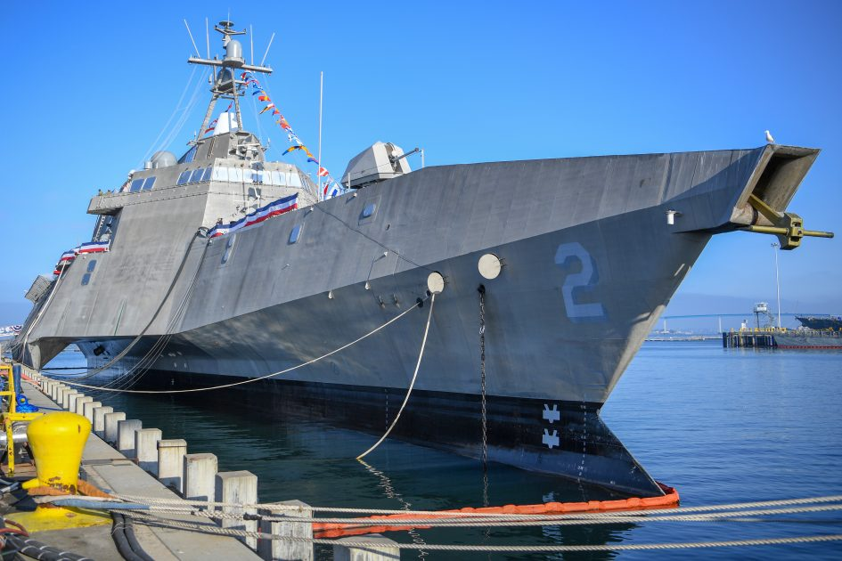
  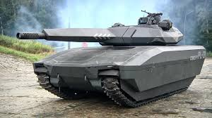
  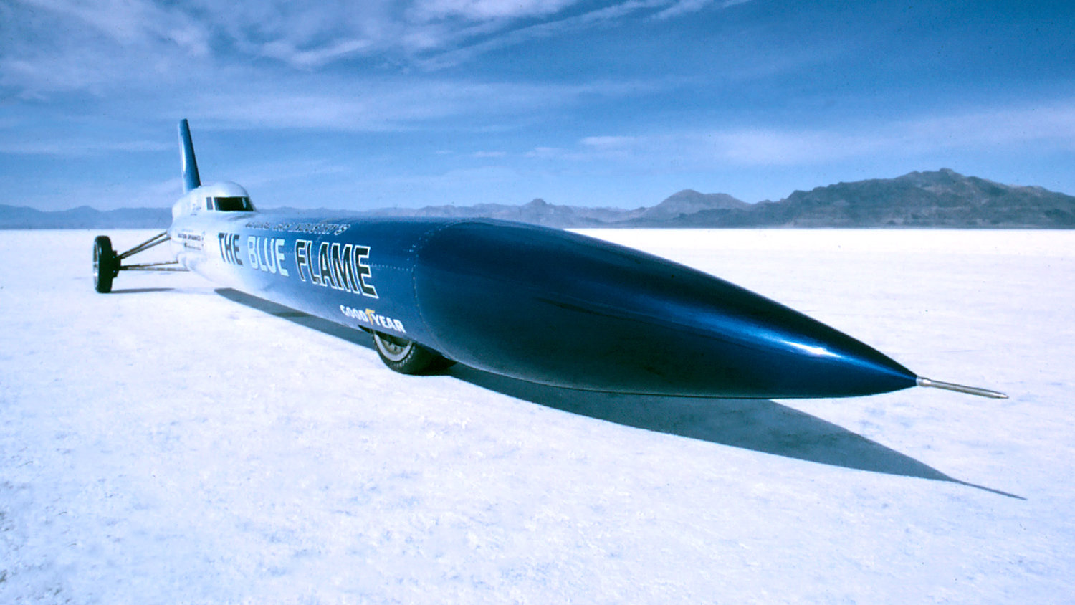
  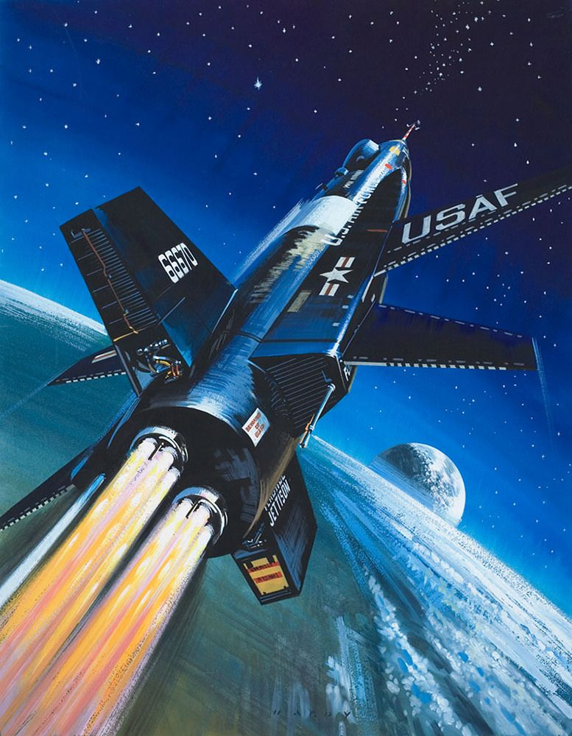
    - f
  Show Theme
  “Pushing the Envelope”
    - October 28, 2023, SAturday
  Features scale model military vehicles, aircraft, ships, cars, trucks, and figures. Vendors offering new and vintage kits, aftermarket items, paints, and tools. Kitchen will be open for breakfast and lunch items.
  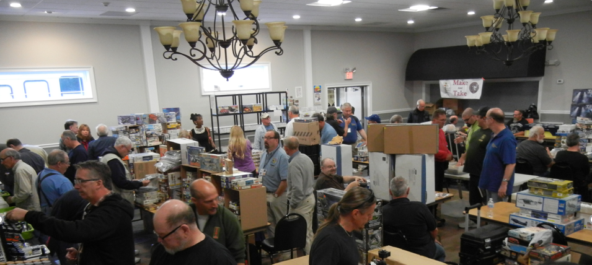
  Elks Club Hall 29 Overrocker Rd Poughkeepsie, NY
  7-10 am Vendor Setup
  9-12 am Contestant Registration
  10-4pm Public
  10-4p-10
  Admission
  Contestants
  First 5 models $10
  6+ $1 per model
  General Public $3
  Family $7 (kids under 12 free)
  
  Contact
  John Gallagher
  ggallagherjoh@gmail.com
  845-462-4740
  Hudson Halley Historical Miniatures IPMS
  http://www.hvhmg.org
Hudson Valley Historical Miniatures Guild

HUDSON VALLEY HISTORICAL MINIATURES GUILD
COMPETITION CATEGORIES
Category/Description

001 Juniors Under 13
002 Juniors 13 to17
101 Aircraft 1/72 & Smaller Prop
102 Aircraft 1/72 & Smaller Jets
103 Aircraft 1/48 & Smaller Single Engine Prop
104 Aircraft 1/48 & Smaller Multi Engine Prop
105 Aircraft 1/48 & Smaller Jets
106 Aircraft Greater then 1/48 All Subjects
107 Aircraft Rotary Wing All Scales & Subjects
201 Armor Less than 1/40 All Subjects
202 Armor Greater than 1/40 Pre 1946 Axis
203 Armor Greater than 1/40 Pre 1946 Allied
204 Armor Greater than 1/40 Post 1946
205 Armor Greater than 1/40 Wheeled
206 Armor Greater than 1/40 Ordnance
301 Figures 25MM (less than 54MM)
302 Figures 54-100MM
303 Figures Greater than 100MM
304 Figures Busts All Scales and Subjects)
401 Ships less than 1/500 All Subjects
402 Ships Greater Than 1/500 All Subjects
501 Automotive Smaller than 1/24
502 Automotive 1/24 Stock
502B Automotive 1/24 Curbside
503 Automotive 1/24 Custom
504 Automotive 1/24 Competition
505 Automotive Greater than 1/24 All subjects
506 Trucks All Scales & Subjects
601 Science Fiction & Fantasy Beings & suits
602 Science Fiction & Fantasy Vehicles
603 Real Space All Scales and Subjects
701 Dioramas All Scales and Subjects
801 Miscellaneous All Scales and Subjects
802Triple Crown
Show Theme – Pushing the Envelope
.net

